# Gas Leak alarm:

*Omkar Anand Iyer*

*EC23B1075*

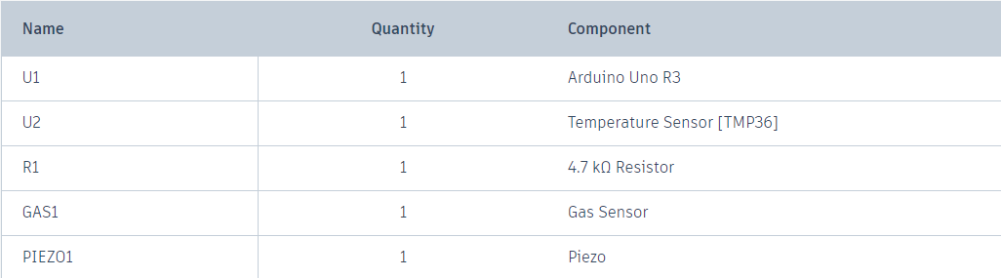**Components used:**

**Working:**

In this project I am detecting a gas leak with gas sensor. If gas leak is detected the buzzer with beep with larger delay. If gas leak is detected and temperature is high there is risk of fire. For that the buzzer will beep rapidly.

**Picture:**

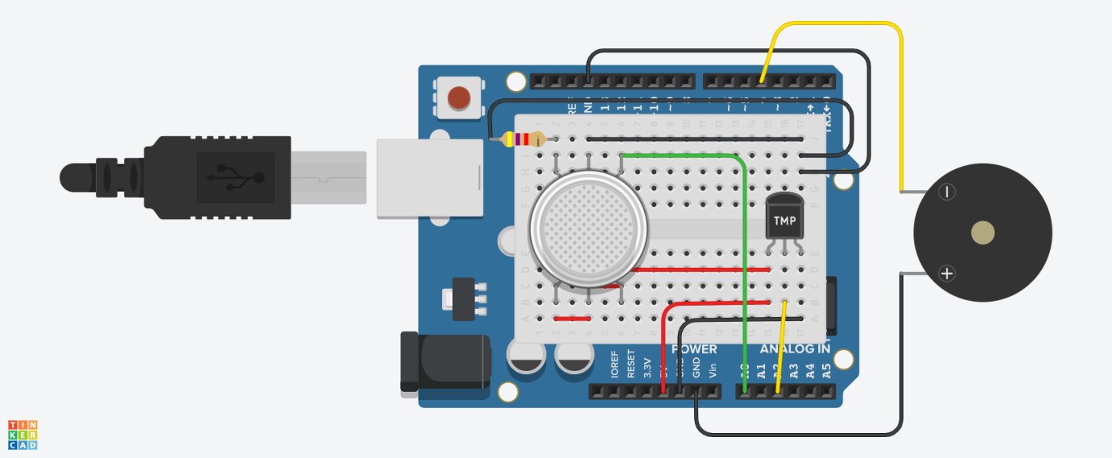

**TinkerCad link:** https://www.tinkercad.com/things/fA8cSxvggyU-gas-leak-alarm?sharecode=WFu7XFCiN3T5tbrAQHrBTFpwRVWpuuvdrIwuyupHg1E